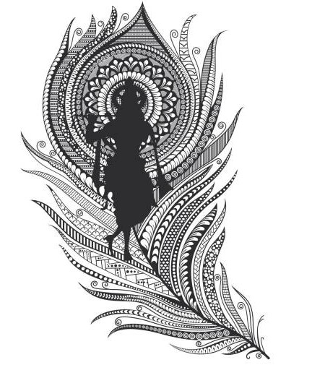

Kirtan Mandli

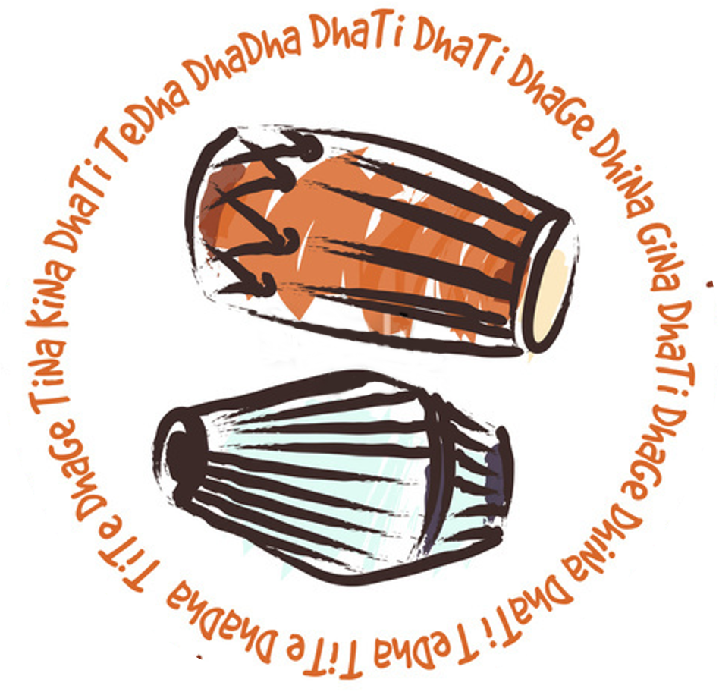

# Basic Bols

|  |  |  |
| --- | --- | --- |
| Bol | Side of Mrdanga |  |
| Ta/Na | Dayan | Index finger of right hand – Open |
| Ti/Tak | Dayan | Two middle fingers - Closed |
| Re/Ne | Dayan | Thumb - Open |
| Ri/Ra | Dayan | Index Finger - Closed |
| Te | Dayan | Four Fingers - Closed |
| Khe/Khi/Ki | Bayan | Fingers spread - Closed |
| Ghe/Ghi | Bayan | Fingers together - Open |
|  | Bayan |  |
| Dha/Jha | Both | Ghe and Ta together |
| Dhe/Dhi | Both | Ghe and Ti together |
| Kha/Tha | Both | Khe and Ta together |
| The | Both | Khe and Ti together |
| Tere/Tiri | Dayan | Ta and Ti in rapid succession (1 beat) |
| Tira | Dayan | Ti and Ta in rapid succession (1 beat) |
| Rati | Dayan | Ra (slap with index finger) Ti (slap with fingers) in rapid succession |
| Gin | Bayan | Strike and slide |

# Kaherva Taal

This first mantra, makes a great introductory pattern, and introduces the first three bols.

Dha, Ta, and Khe.

When playing each bol, say the words out loud, this will help to memorise patterns.

|  |  |  |  |  |  |  |  |
| --- | --- | --- | --- | --- | --- | --- | --- |
| 1 | & | 2 | & | 3 | & | 4 | & |
| Dha |  | Ta | Khe | Ta |  | Dha | Ge |

This Next mantra creates a nice medium pace rythym for kirtan

Remember, the bol Na, is a synonym for Ta.

|  |  |  |  |  |  |  |  |
| --- | --- | --- | --- | --- | --- | --- | --- |
| 1 | & | 2 | & | 3 | & | 4 | & |
| Dha |  | Ge |  | Ti |  | Kha |  |
| Na |  | Ge |  | Dhi |  | Na |  |

Finally, this fast paced mantra is used when the kirtan speeds up

|  |  |  |  |  |  |  |  |
| --- | --- | --- | --- | --- | --- | --- | --- |
| 1 | a | & | a | 2 | a | & | a |
| Ge |  |  | Ti | Kha |  | Ge Dhi | Na |
| Na |  | Ge |  | Dhi |  | Na |  |

This next mantra, is good for practice, and can be built upon for more complex rythms.

|  |  |  |  |  |  |  |  |
| --- | --- | --- | --- | --- | --- | --- | --- |
| 1 | & | 2 | & | 3 | & | 4 | & |
| Ta |  | Khe | Ta | Ge |  | Ge |  |

Simply by adding another Khe, we can begin to build our bol.

|  |  |  |  |  |  |  |  |
| --- | --- | --- | --- | --- | --- | --- | --- |
| 1 | & | 2 | & | 3 | & | 4 | & |
| Ta | Khe |  | Khe | Ta | Ge | Ge |  |

And adding a Ti on the second beat, completes the bol

|  |  |  |  |  |  |  |  |
| --- | --- | --- | --- | --- | --- | --- | --- |
| 1 | & | 2 | & | 3 | & | 4 | & |
| Ta | Khe | Ti | Khe | Ta | Ge | Ge |  |

# Tihai

1. In modern drumming, a tihai would be called a fill.
2. Tihai represents when there is going to be a change in beat, or rhythm.
3. Usually, a te hai is a set of three bols. Eg: Ta Khe-Ta Jha three times to complete the 4 beats.

|  |  |  |  |  |  |  |  |
| --- | --- | --- | --- | --- | --- | --- | --- |
| 1 | & | 2 | & | 3 | & | 4 | & |
| **ta** |  | **khe** | **ta** | **jha** |  | **ta** |  |
| **khe** | **ta** | **jha** |  | **ta** |  | **khe** | **ta** |

A Tihai, may also overflow bars, as shown here, a 3 beat Tihai, overflows the four beats.

Recall that tira is ti and ra played in rapid success to form a single beat

|  |  |  |  |  |  |  |  |  |  |  |  |  |  |  |  |
| --- | --- | --- | --- | --- | --- | --- | --- | --- | --- | --- | --- | --- | --- | --- | --- |
| **1** | **a** | **2** | **a** | **3** | **a** | **4** | **a** | **5** | **a** | **6** | **a** | **7** | **a** | **7** | **a** |
| **ti** | **ra** | **khi** | **ta** | **dha** |  | **ti** | **ra** | **ki** | **ta** | **dha** |  | **ti** | **ra** | **khi** | **ta** |

This Tihai, uses Tha kita Tha twice, and finishes with a single Tha on the final beat

|  |  |  |  |  |  |  |  |
| --- | --- | --- | --- | --- | --- | --- | --- |
| 1 | & | 2 | & | 3 | & | 4 | & |
| **Tha** | **kita** | **Tha** | **Tha** | **kita** | **ta** | **Tha** |  |

If we combine some of the above bols, we can make even more complex tihai’s

Recall that tira is ti and ra played in rapid success to form a single beat, and kita is

|  |  |  |  |  |  |  |  |
| --- | --- | --- | --- | --- | --- | --- | --- |
| 1 | 2 | 3 | 4 | 5 | 6 | 7 | 8 |
| **tira** | **kita** | **Dha** | **tira** | **kita** | **Dha** | **tira** | **kita** |

# Eight Beat Mantras

A common pattern in many kirtans, is to play a three rounds of a standing rythym, followed by a Tehai.

|  |  |  |  |  |  |  |  |
| --- | --- | --- | --- | --- | --- | --- | --- |
| 1 | & | 2 | & | 3 | & | 4 | & |
| Dha | Ge | Ti | Kha | Na | Ge | Dhi | Na |

## Bhajani Taal

**8-beat mantra often used in the medium to fast part of a kirtan**

|  |  |  |  |  |  |  |  |
| --- | --- | --- | --- | --- | --- | --- | --- |
| 1 | & | 2 | & | 3 | & | 4 | & |
| Ge |  | Ta |  | Ge | Ge | Dha |  |
| Ge |  | Ta |  | Khe | Khe | Ta |  |

By doubling the Ge, this rhythm can be filled out a little

|  |  |  |  |  |  |  |  |
| --- | --- | --- | --- | --- | --- | --- | --- |
| 1 | & | 2 | & | 3 | & | 4 | & |
| Ge | Ge | Ta |  | Ge | Ge | Dha |  |
| Ge | Ge | Ta |  | Khe | Khe | Ta |  |

**This next mantra, is a rolling beat, used when particularly in longer kirtans**

|  |  |  |  |  |  |  |  |
| --- | --- | --- | --- | --- | --- | --- | --- |
| 1 | & | 2 | & | 3 | & | 4 | & |
| Dha |  |  |  | Ti |  | Dha |  |
| Ti |  | Dha |  | Khe |  | Dha |  |

**The second half of the above mantra can be also be used on its own**

|  |  |  |  |  |  |  |  |
| --- | --- | --- | --- | --- | --- | --- | --- |
| 1 | & | 2 | & | 3 | & | 4 | & |
| Ti |  | Dha |  | Khe |  | Dha |  |

Kaherva Taal

|  |  |  |  |  |  |  |  |  |  |  |  |  |  |  |  |
| --- | --- | --- | --- | --- | --- | --- | --- | --- | --- | --- | --- | --- | --- | --- | --- |
| **1** | **&** | **2** | **&** | **3** | **&** | **4** | **&** | **5** | **&** | **6** | **&** | **7** | **&** | **8** | **&** |
| Dha |  |  | Ge | Ti |  | Kha |  | Ti |  | Kha |  | Dhi |  | Na |  |

**Kaherva Taal has almost limitless variations. Try this one.**

|  |  |  |  |  |  |  |  |  |  |  |  |  |  |  |  |
| --- | --- | --- | --- | --- | --- | --- | --- | --- | --- | --- | --- | --- | --- | --- | --- |
| **1** | **&** | **2** | **&** | **3** | **&** | **4** | **&** | **5** | **&** | **6** | **&** | **7** | **&** | **8** | **&** |
| **dha** |  | **dha** |  | **ti** |  | **kha** |  | **ti** |  | **dha** |  | **dhi** |  | **na** |  |

## More Beats

|  |  |  |  |  |  |  |  |
| --- | --- | --- | --- | --- | --- | --- | --- |
| **1** | **&** | **2** | **&** | **3** | **&** | **4** | **&** |
| **Khe** |  | **Ta** | **Khe** | **Ti** | **Ghe** | **Dha** |  |

This is in 3/4 time.

|  |  |  |  |  |  |  |  |  |  |  |  |
| --- | --- | --- | --- | --- | --- | --- | --- | --- | --- | --- | --- |
| **1** | **&** | **a** | **2** | **&** | **a** | **3** | **&** | **a** | **4** | **&** | **a** |
| **Ta** |  |  | **Khe** | **Ta** | **Khe** | **Ta** |  |  | **Khe** | **Ta** | **Khe** |

|  |  |  |  |  |  |  |  |  |  |  |  |
| --- | --- | --- | --- | --- | --- | --- | --- | --- | --- | --- | --- |
| **5** | **&** | **a** | **6** | **&** | **a** | **7** | **&** | **a** | **7** | **&** | **a** |
| **Ta** |  |  | **Khe** | **Ta** | **Khe** | **Ta** |  |  | **Ghe** | **Ta** | **Ghe** |

**Fast Beat**

|  |  |  |  |  |  |  |  |
| --- | --- | --- | --- | --- | --- | --- | --- |
| **1** | **&** | **2** | **&** | **3** | **&** | **4** | **&** |
| **Ghe** |  | **Ti** | **Kha** |  | **Ghe** | **Khe** | **Na** |

## Slow Beats

|  |  |  |  |  |  |  |  |
| --- | --- | --- | --- | --- | --- | --- | --- |
| 1 | 2 | 3 | 4 | 5 | 6 | 7 | 8 |
| **ta** |  |  | **khi** | **ta** | **ghe** | **ghe** |  |

|  |  |  |  |  |  |  |  |  |  |  |  |  |  |  |  |
| --- | --- | --- | --- | --- | --- | --- | --- | --- | --- | --- | --- | --- | --- | --- | --- |
| **1** | **a** | **&** | **a** | **2** | **a** | **&** | **a** | **3** | **a** | **&** | **a** | **4** | **a** | **&** | **a** |
| **dhi** |  |  | **ta** | **ti** |  | **Tha** |  | **ti** |  |  | **ta** | **dhi** |  | **na** |  |

# Dash Pera (Prabhupad) Taal

|  |  |  |  |  |  |  |  |  |  |  |  |  |  |  |  |  |
| --- | --- | --- | --- | --- | --- | --- | --- | --- | --- | --- | --- | --- | --- | --- | --- | --- |
| **1** |  | **a** | **&** | **a** | **2** | **a** | **&** | **a** | **3** | **a** | **&** | **a** | **4** | **a** | **&** | **a** |
| Dha |  |  |  |  |  |  |  |  | Ti |  |  |  | Ta |  |  |  |
| Ta |  |  |  |  | Ti |  | Ta |  | Ti |  | Ta |  |  |  |  |  |
| Kha |  |  |  |  | Ki |  |  |  | Na |  |  |  | Dha |  |  |  |
| Ge |  |  |  |  | Dha |  |  |  | Ge |  |  |  | Dha |  |  |  |

|  |  |  |  |  |  |  |  |  |  |  |  |  |  |  |  |
| --- | --- | --- | --- | --- | --- | --- | --- | --- | --- | --- | --- | --- | --- | --- | --- |
| **1** | **a** | **&** | **a** | **2** | **a** | **&** | **a** | **3** | **a** | **&** | **a** | **4** | **a** | **&** | **a** |
| Khe |  |  |  |  |  |  | Khe | Ti |  |  |  | Ge |  |  |  |
| Dha |  |  |  | Ge |  |  |  | Dha |  |  |  |  |  |  |  |
| Ge |  |  |  | Dha |  |  |  | Dha |  |  |  | Ta |  |  |  |
| Ta |  |  |  |  |  |  |  |  |  |  |  | Ta |  |  |  |

|  |  |  |  |  |  |  |  |  |  |  |  |  |  |  |  |
| --- | --- | --- | --- | --- | --- | --- | --- | --- | --- | --- | --- | --- | --- | --- | --- |
| **1** | **a** | **&** | **a** | **2** | **a** | **&** | **a** | **3** | **a** | **&** | **a** | **4** | **a** | **&** | **a** |
|  |  | Khe | Ti | Ge |  | Dha |  | Ge |  | Dha | Ge | Dha |  | Dha |  |
| Ha | re |  |  | Krish |  | na |  | Ha |  | re |  | Krish |  | na |  |
|  |  |  |  |  |  | Ta |  | Ta |  |  |  | Ta |  | Khe |  |
| Krish |  | na |  | Krish |  | na |  | Ha |  | re |  | Na |  | re |  |
|  |  | Khe | Ti | Ge |  | Dha |  | Ge | Dha | Ge |  | Dha |  | Dha |  |
| Ha |  | re |  | Ra |  | ma |  | Ha |  | re |  | Ra |  | ma |  |
|  |  |  |  |  |  | Ta |  | Ta |  |  |  | Ta |  | Khe |  |
| Ra |  | ma |  | Ra |  | ma |  | Ha |  | re |  | Ha |  | re |  |

|  |  |  |  |  |  |  |  |  |  |  |  |  |  |  |  |
| --- | --- | --- | --- | --- | --- | --- | --- | --- | --- | --- | --- | --- | --- | --- | --- |
| **1** | **a** | **&** | **a** | **2** | **&** | **a** | **a** | **3** | **a** | **&** | **a** | **4** | **a** | **&** | **a** |
| Khe | Ti Ge | | | Dha |  | Ge |  | Dha |  | Ge |  | Dha |  | Dha |  |
| Ha |  | re |  | Krish |  | na |  | Ha |  | re |  | Krish |  | na |  |
|  |  |  |  |  |  | Ta |  | Ta |  |  |  | Ta |  | Khe |  |
| Krish |  | na |  | Krish |  | na |  | Ha |  | re |  | Na |  | re |  |
| Khe | Ti | Ge |  | Dha |  | Ga |  | Dha |  | Ge |  | Dha |  | Dha |  |
| Ha |  | re |  | Ra |  | ma |  | Ha |  | re |  | Ra |  | ma |  |
|  |  |  |  |  |  | Ta |  | Ta |  |  |  | Ta |  | Khe |  |
| Ra |  | ma |  | Ra |  | ma |  | Ha |  | re |  | Ha |  | re |  |

**First Prakar (Variation)**

|  |  |  |  |  |  |  |  |  |  |  |  |  |  |  |  |
| --- | --- | --- | --- | --- | --- | --- | --- | --- | --- | --- | --- | --- | --- | --- | --- |
| **1** | **a** | **&** | **a** | **2** | **a** | **&** | **a** | **3** | **a** | **&** | **a** | **4** | **a** | **&** | **a** |
| Khe |  |  | Khe | Na |  | Dha |  | Ge |  | Dha |  | Ge |  | Dha |  |
| Dhi |  |  |  | Dhi |  | Ta |  | Ta |  | Tere |  | Tere |  | Ta |  |

**Second Prakar (Variation)**

|  |  |  |  |  |  |  |  |  |  |  |  |  |  |  |  |
| --- | --- | --- | --- | --- | --- | --- | --- | --- | --- | --- | --- | --- | --- | --- | --- |
| **1** | **2** | **3** | **4** | **5** | **6** | **7** | **8** | **9** | **10** | **11** | **12** | **13** | **14** | **15** | **16** |
| Dha |  | Ti | Ta | Ta | Rati | Rati | Ta | Ki | Tiki | TaGe | Dha | Dhi | Dha | Dhi | Dha |

**Third Prakar (Variation)**

|  |  |  |  |  |  |  |  |  |  |  |  |  |  |  |  |
| --- | --- | --- | --- | --- | --- | --- | --- | --- | --- | --- | --- | --- | --- | --- | --- |
| **1** | **a** | **&** | **a** | **2** | **a** | **&** | **a** | **3** | **a** | **&** | **a** | **4** | **a** | **&** | **a** |
| Dha |  |  |  |  |  |  | Gin | Ti |  |  |  | Ta |  |  |  |
| Ta |  |  |  | Ra |  | ti |  | Ra |  | ti |  | Ta |  |  |  |
| Ki |  |  |  |  |  |  | Ki | Ti |  | Ge |  | Dha |  |  |  |
| Dhi |  |  |  | Dha |  |  |  | Dhi |  |  |  | Dha |  |  |  |

Based on this first Prabhupad mantra, we can define new mantras.

|  |  |  |  |  |  |  |  |
| --- | --- | --- | --- | --- | --- | --- | --- |
| **1** | **&** | **2** | **&** | **3** | **&** | **4** | **&** |
| Khe |  | Ta | Khe | Ti | Ge | Dha |  |

**Lofa Taal**

|  |  |  |  |  |  |
| --- | --- | --- | --- | --- | --- |
| **1** | **&** | **a** | **2** | **&** | **a** |
| Dha | Ghe Na | Khe Ta | Dhe | Ghe Na | Ghe Na |

## First Prakar (Variation)

|  |  |  |  |  |  |  |  |  |  |  |  |  |  |  |  |
| --- | --- | --- | --- | --- | --- | --- | --- | --- | --- | --- | --- | --- | --- | --- | --- |
| **1** | **a** | **&** | **a** | **2** | **a** | **&** | **a** | **3** | **a** | **&** | **a** | **4** | **a** | **&** | **a** |
| Khe |  |  | Khe | Na |  | Dha |  | Ge |  | Dha |  | Ge |  | Dha |  |
| Dhi |  |  |  | Dhi |  | Ta |  | Ta |  | Tere |  | Tere |  | Ta |  |

## Second Prakar (Variation)

|  |  |  |  |  |  |  |  |  |  |  |  |  |  |  |  |
| --- | --- | --- | --- | --- | --- | --- | --- | --- | --- | --- | --- | --- | --- | --- | --- |
| **1** | **2** | **3** | **4** | **5** | **6** | **7** | **8** | **9** | **10** | **11** | **12** | **13** | **14** | **15** | **16** |
| Dha |  | Ti | Ta | Ta | Rati | Rati | Ta | Ki | Tiki | TaGe | Dha | Dhi | Dha | Dhi | Dha |

## Third Prakar (Variation)

|  |  |  |  |  |  |  |  |  |  |  |  |  |  |  |  |
| --- | --- | --- | --- | --- | --- | --- | --- | --- | --- | --- | --- | --- | --- | --- | --- |
| **1** | **a** | **&** | **a** | **2** | **a** | **&** | **a** | **3** | **a** | **&** | **a** | **4** | **a** | **&** | **a** |
| Dha |  |  |  |  |  |  | Gin | Ti |  |  |  | Ta |  |  |  |
| Ta |  |  |  | Ra |  | ti |  | Ra |  | ti |  | Ta |  |  |  |
| Ki |  |  |  |  |  |  | Ki | Ti |  | Ge |  | Dha |  |  |  |
| Dhi |  |  |  | Dha |  |  |  | Dhi |  |  |  | Dha |  |  |  |

Based on this first Prabhupad mantra, we can define new mantras.

|  |  |  |  |  |  |  |  |
| --- | --- | --- | --- | --- | --- | --- | --- |
| **1** | **&** | **2** | **&** | **3** | **&** | **4** | **&** |
| Khe |  | Ta | Khe | Ti | Ge | Dha |  |

## Another 16 Beat Kirtan Bol

This is a great beat for mantra’s, as the second and third bols can be removed as the kirtan pace increases, and only the 1st and 4th bols used.

|  |  |  |  |  |  |  |  |
| --- | --- | --- | --- | --- | --- | --- | --- |
| **1** | **&** | **2** | **&** | **3** | **&** | **4** | **&** |
| Khe |  | Ta | Khe | Ti | Ge | Dha |  |

|  |  |  |  |  |  |  |  |
| --- | --- | --- | --- | --- | --- | --- | --- |
| **1** | **&** | **2** | **&** | **3** | **&** | **4** | **&** |
| Khe |  | Ta | Khe | Ti | Ge | Dha |  |

|  |  |  |  |  |  |  |  |
| --- | --- | --- | --- | --- | --- | --- | --- |
| **1** | **&** | **2** | **&** | **3** | **&** | **4** | **&** |
| Khe |  | Ta | Khe | Ti | Ge | Dha |  |

|  |  |  |  |  |  |  |  |
| --- | --- | --- | --- | --- | --- | --- | --- |
| **1** | **&** | **2** | **&** | **3** | **&** | **4** | **&** |
| Khe |  | Ta | Khe | Ti | Ge | Dha |  |

## Lofa Taal

**Lofa Taal**

|  |  |  |  |  |  |
| --- | --- | --- | --- | --- | --- |
| **1** | **&** | **a** | **2** | **&** | **a** |
| Dha | Ghe Na | Khe Ta | Dhe | Ghe Na | Ghe Na |

# Faster Beats

When a Kirtan really begins to jump, and the speed accelerates, try switching to these beats.

|  |  |  |  |  |  |  |  |
| --- | --- | --- | --- | --- | --- | --- | --- |
| **1** | **&** | **2** | **&** | **3** | **&** | **4** | **&** |
| Dhi |  | Na | Tha | Ti | Ge | Dha | Ta |

This is a beginners fast beat, which we can build upon

|  |  |  |  |  |  |  |  |
| --- | --- | --- | --- | --- | --- | --- | --- |
| **1** | **&** | **2** | **&** | **3** | **&** | **4** | **&** |
| Dha |  |  | Khi | na | Ghe | Dhi |  |

This is a more intermediate fast beat,

|  |  |  |  |  |  |  |  |
| --- | --- | --- | --- | --- | --- | --- | --- |
| **1** | **&** | **2** | **&** | **3** | **&** | **4** | **&** |
| Dha |  | The | Na | Ghe | Ghe | Dhi |  |

4) This is a more intermediate fast beat,

|  |  |  |  |  |  |  |  |
| --- | --- | --- | --- | --- | --- | --- | --- |
| **1** | **&** | **2** | **&** | **3** | **&** | **4** | **&** |
| Dha |  | The | Na | Ghe | Ghe | Dhi |  |

5) Another excellent bol, which can be used from slow, through the middle, and to the end.

|  |  |  |  |  |  |  |  |
| --- | --- | --- | --- | --- | --- | --- | --- |
| **1** | **&** | **2** | **&** | **3** | **&** | **4** | **&** |
| Dhi |  | Te | Tha |  | Ghe | Dhi | Na |

# Teen Taal (Tin Taal)

While not often used in kirtan, this 16 beat matra is quite popular in Indian music

|  |  |  |  |  |  |  |  |  |  |  |  |  |  |  |  |
| --- | --- | --- | --- | --- | --- | --- | --- | --- | --- | --- | --- | --- | --- | --- | --- |
| X |  |  |  | 2 |  |  |  | 0 |  |  |  | 3 |  |  |  |
| 1 | 2 | 3 | 4 | 5 | 6 | 7 | 8 | 9 | 10 | 11 | 12 | 13 | 14 | 15 | 16 |
| Dha | Dhin | Dhin | Dha | Dha | Dhin | Dhin | Dha | Dha | Ti | Ti | Ta | Ta | Dhin | Dhin | Dha |

# Three Beat Mantras

## Thee Beat Variation

|  |  |  |  |  |  |
| --- | --- | --- | --- | --- | --- |
| **1** | **&** | **2** | **&** | **3** | **&** |
| Tak |  | Ta |  | Khi | Khi |
| Tak |  | Jha |  | Ge |  |
| Dhe |  | Na |  | Ge |  |
| Dhe |  | Na |  |  |  |

**The three beat pattern, gives a different feel to a mantra, such as Damodarastakam.**

## Thee Beat 2nd Variation

|  |  |  |  |  |  |
| --- | --- | --- | --- | --- | --- |
| **1** | **&** | **2** | **&** | **3** | **&** |
| Tak |  | Ta |  | Khi | Khi |
| Dha | Ge | Dha |  | Ge |  |
| Dhe |  | Na |  | Ge | Ge |
| Dhe |  | Na |  |  |  |

# Exercises

## Exercise 1

|  |  |  |  |
| --- | --- | --- | --- |
| 1 | 2 | 3 | 4 |
| Dha | Ge | Ti | Kha |
| Na | Ge | Dhi | Na |

In this bol, there is more emphasis on the off-beat

## Exercise 2

|  |  |  |  |  |  |  |  |
| --- | --- | --- | --- | --- | --- | --- | --- |
| 1 | & | 2 | & | 3 | & | 4 | & |
| Ta |  |  | Khe | Ta | Ge | Dha |  |

## Exercise 3

|  |  |  |  |  |  |  |  |
| --- | --- | --- | --- | --- | --- | --- | --- |
| 1 | & | 2 | & | 3 | & | 4 | & |
| Ki Ta | Ghe | Dha |  | Dha |  |  |  |

## Exercise 4

|  |  |  |  |  |  |  |  |
| --- | --- | --- | --- | --- | --- | --- | --- |
| 1 | & | 2 | & | 3 | & | 4 | & |
| Ki | Ta | Ghe | Dha |  | Ta | Ghe | Dha |

## Exercise 5

|  |  |  |  |  |  |  |  |
| --- | --- | --- | --- | --- | --- | --- | --- |
| 1 | & | 2 | & | 3 | & | 4 | & |
| Ghe | Dha | Dha | Dha | Ta | Ghe | Dha | Ta |

## Exercise 6

|  |  |  |  |  |  |  |  |
| --- | --- | --- | --- | --- | --- | --- | --- |
| 1 | & | 2 | & | 3 | & | 4 | & |
| Ki | Ta | Ghe | Dha |  | Ta | Ghe | Dha |

# Hand Practice

**Practice each mantra for at least 10 minutes.**

Say the bols aloud as you play them, and speed up slowly as your skill improves.

## Tere Kheta

Note, in this practice **Ta** is played with four fingers, instead of one. Open sound.

When using four fingers, keeping the fingers together (like a mitten) is important, because when played fast, having the fingers open, will slow you down

|  |  |  |  |
| --- | --- | --- | --- |
| **1** | **2** | **3** | **4** |
| **Te** | **Re** | **Khe** | **Ta** |

## Tere Tere Kheta

This practice bol, builds on the previous one, by adding another TeRe.

|  |  |  |  |  |  |  |  |  |  |
| --- | --- | --- | --- | --- | --- | --- | --- | --- | --- |
| **1** | **2** | **3** | **4** | **5** | **6** | **7** | **8** | **9** | **10** |
| **Te** | **Re** | **Khe** | **Ta** | **Te** | **Re** | **Te** | **Re** | **Kh** | **ta** |

## Right Hand Strengthening

P say there is no better way to build strength, and stamina, for the right hand.

|  |  |  |  |  |  |  |  |
| --- | --- | --- | --- | --- | --- | --- | --- |
| **1** | **2** | **3** | **4** | **5** | **6** | **7** | **8** |
| **Tere** | **Kheta** | **Tere** | **Kheta** | **Tere** | **Tere** | **Tere** | **Kheta** |
| **Tikhi** | **Takhi** | **Tere** | **Tere** | **Kheta** | **Takhi** | **Tere** | **Kheta** |

The first 8 beats are derived from the first two practices.  
The second line begins with **Tikhi**, which, for the purpose of this practice, **Ti** is played with four fingers and closed sound). And **khi** is played with a closed hand on the Bayan.

**Takhi**, is played with **Ta**, as in the previous practice bols, with four fingers and an open sound, and **khi** is again, played with open hand on the Bayan.

As you can see on the second line in beats 5 and 6, there is a **Ta** on the end of **Kheta** in beat 5, and **Ta** at the beginning of beat six. Having to **Ta**’s together would be very tiring at high speeds, so we replace the **Kheta** on beat 5, with a **Re** (thumb with open sound), making it **Khere**.